**Step for List:**

1. **You can access the list on by going on this page:**

<http://143.198.214.24:2337/admin/plugins/content-manager/collectionType/application::how-it-works.how-it-works>

You should be showing this page:

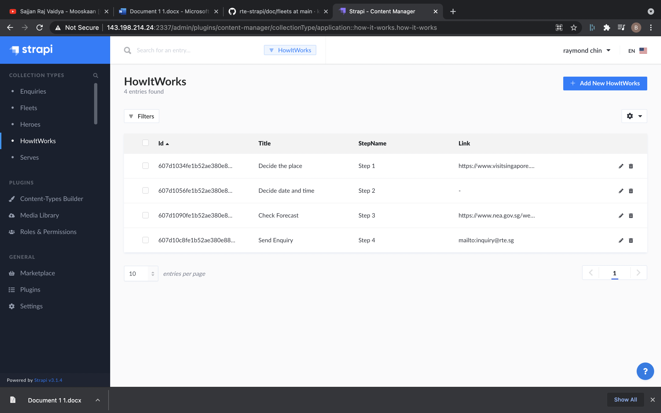

## **Steps for Add:**

### **1. Visit link to add new:**

<http://143.198.214.24:2337/admin/plugins/content-manager/collectionType/application::how-it-works.how-it-works/create>

This should be the page shown:

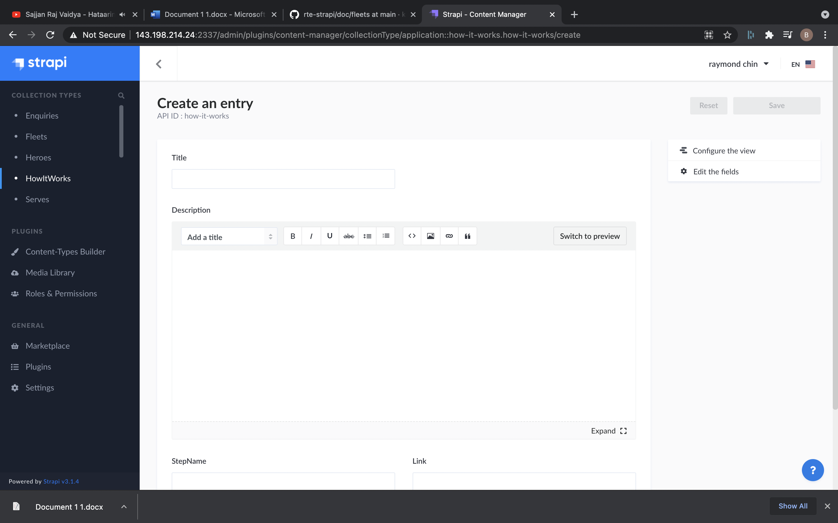

### **2. Add the details for new:**

a. Title: This will be title.

b. Description: This will be the description.

c. StepName: This will be name of step. Eg: Step-1, Step-2,etc.

d. Link: This will be the link if we want to link for some link. Leave blank to hide the button.

e. linkText: This will be text of Link as Visit, Enquiry

### **3. Click on save button on top right to save the new.**

## **Steps for delete:**

### **1. Go to List:**

<http://143.198.214.24:2337/admin/plugins/content-manager/collectionType/application::how-it-works.how-it-works>

### **2. Click on data that need to delete:**

It should open the detail, confirm all the details and make sure: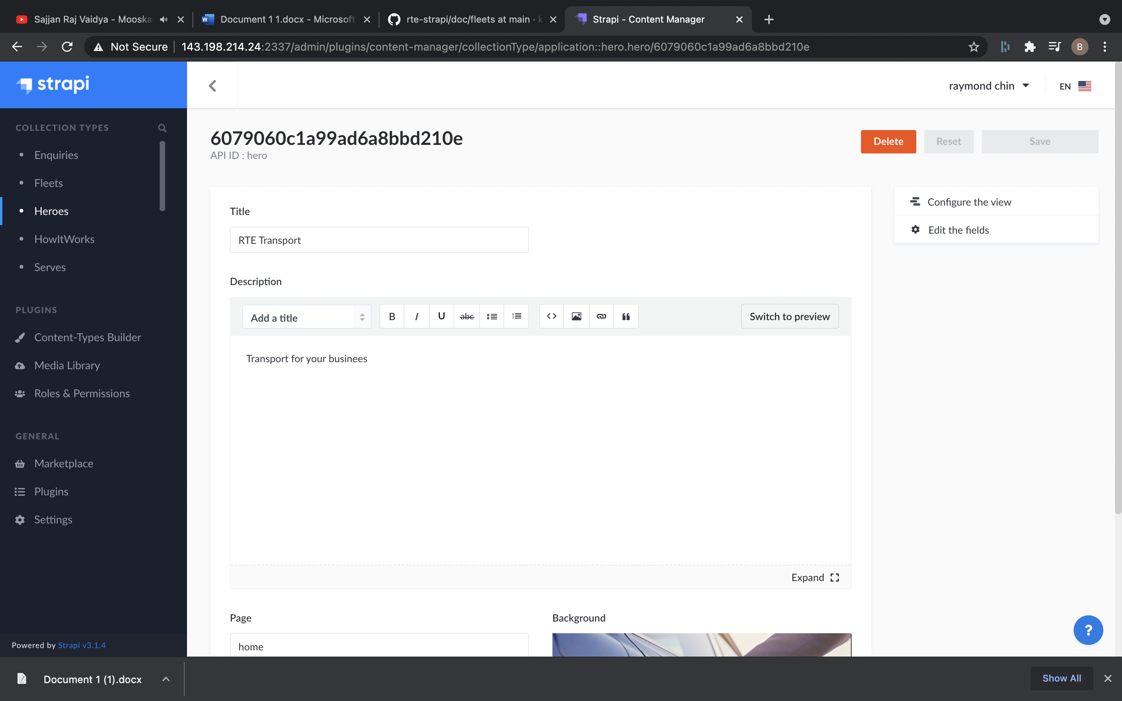

### **3. Click on delete button on top right:**

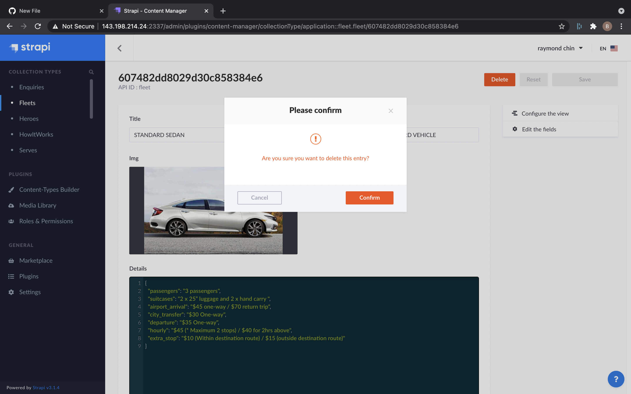

### **4. Click on Confirm to Delete.**

## **Steps for Edit:**

### **1. Go to List:**

<http://143.198.214.24:2337/admin/plugins/content-manager/collectionType/application::how-it-works.how-it-works>

### **2. Click on data that need to edit:**

It should open the detail, confirm all the details and make sure:

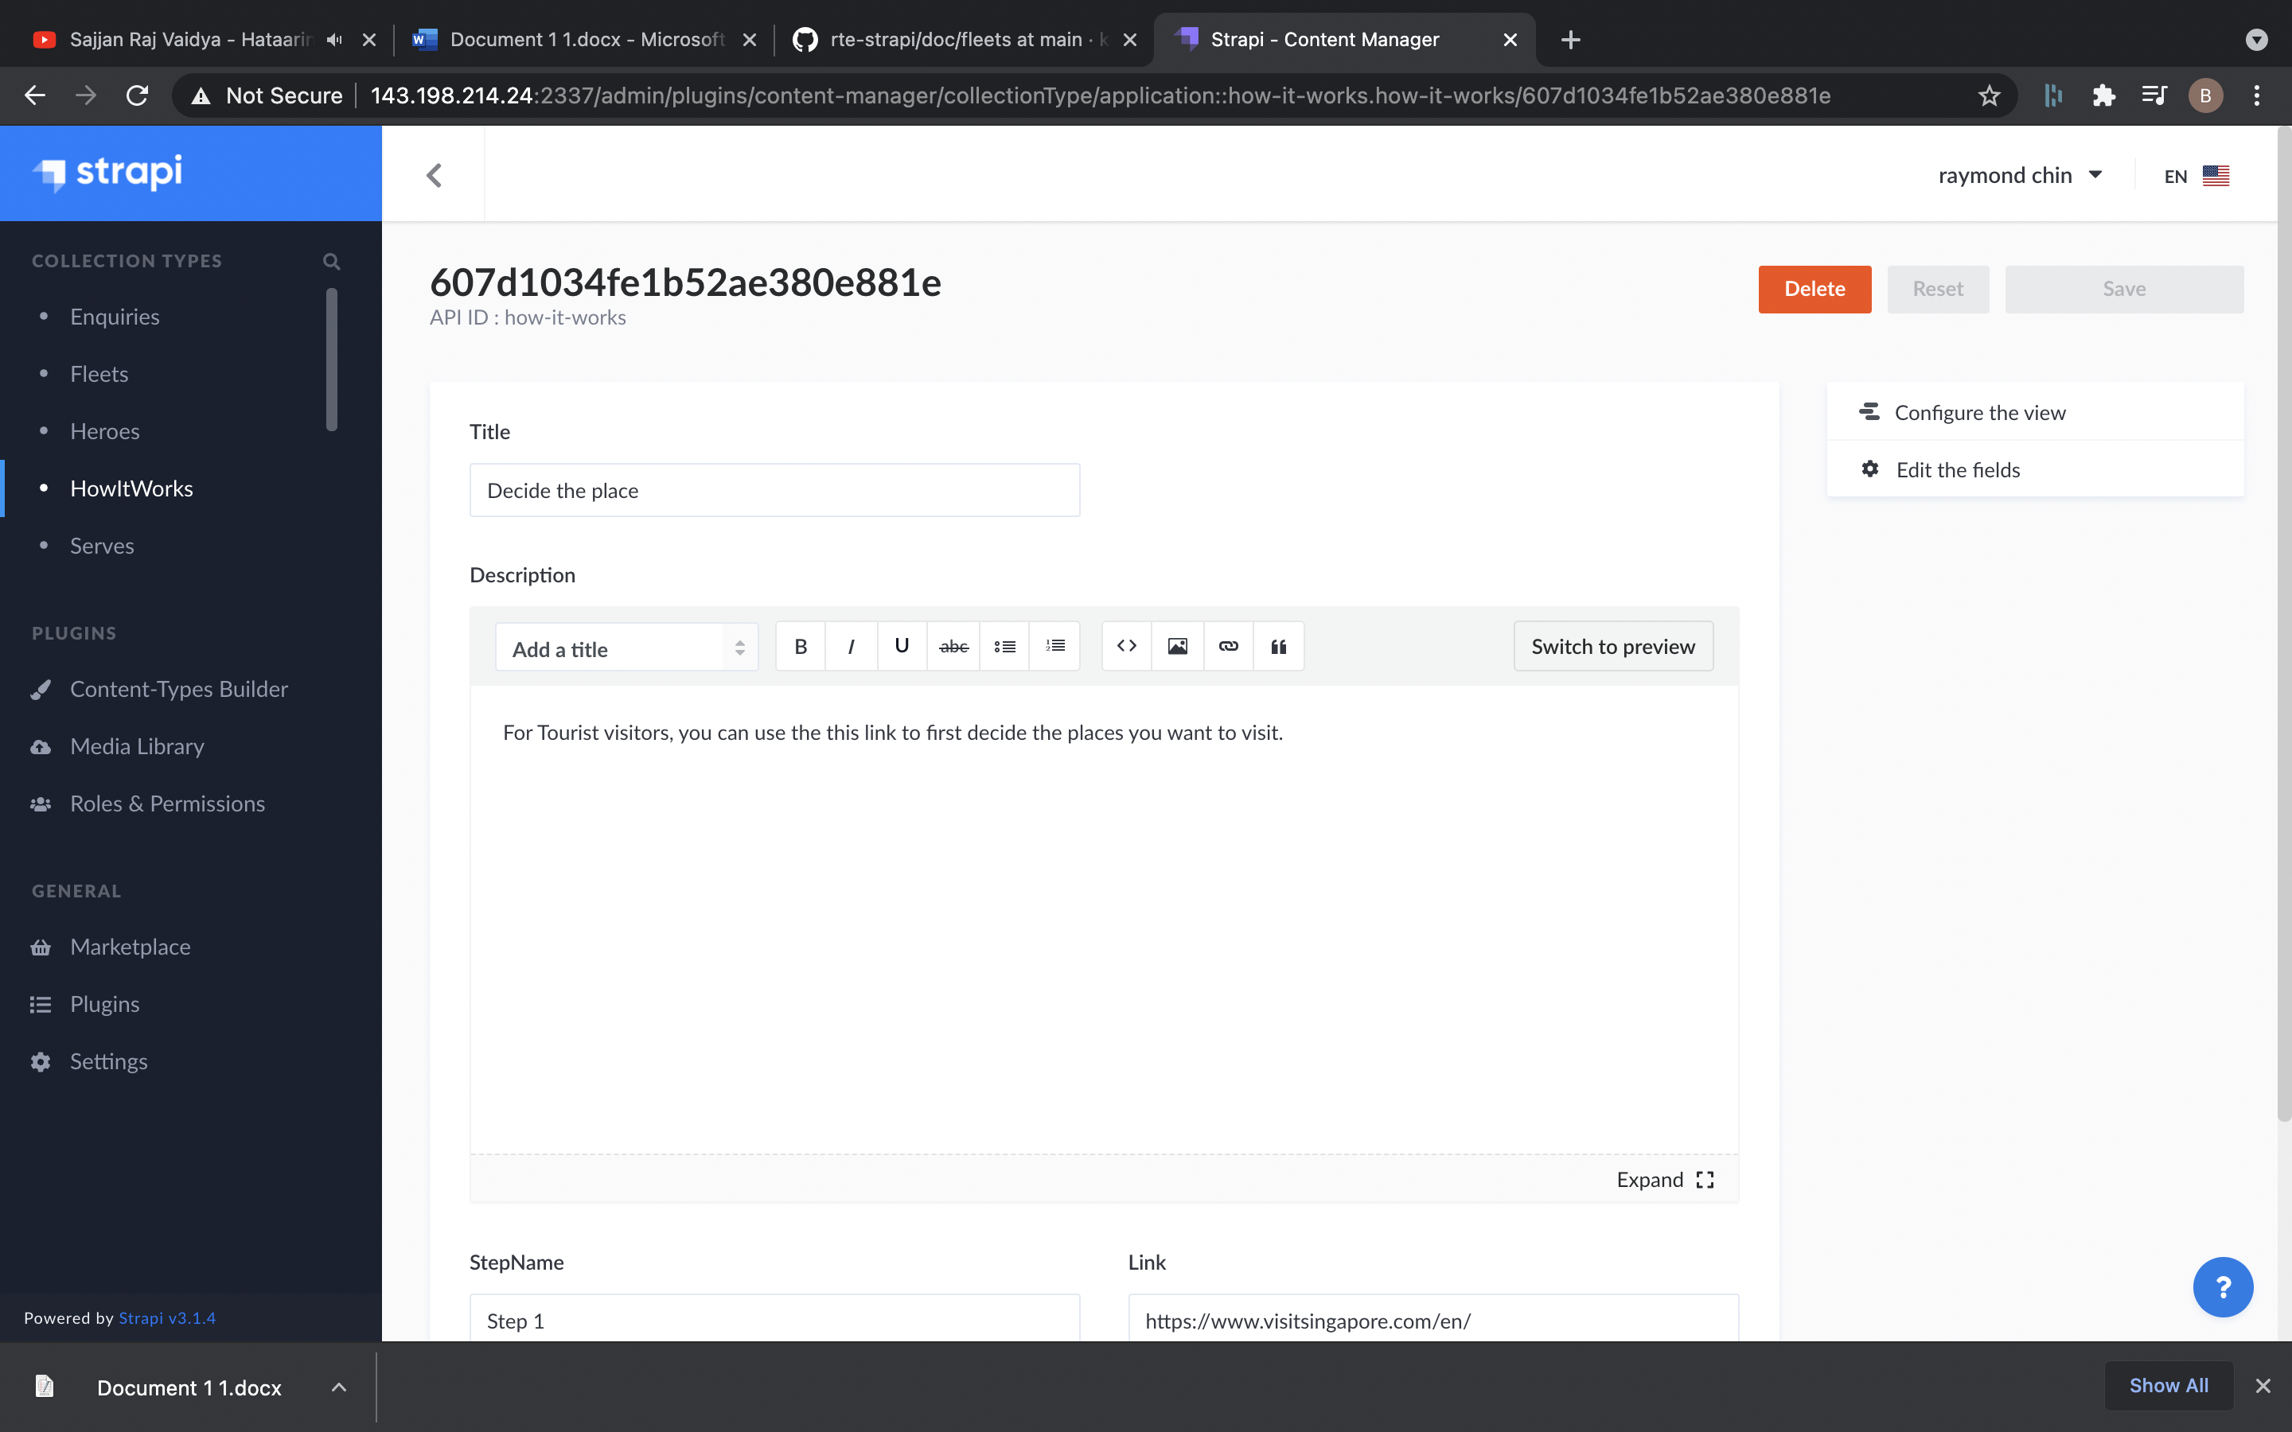

### **3. Edit the details :**

a. Title: This will be title.

b. Description: This will be the description.

c. StepName: This will be name of step. Eg: Step-1, Step-2,etc.

d. Link: This will be the link if we want to link for some link. Leave blank to hide the button.

e. linkText: This will be text of Link as Visit, Enquiry

### **4. Click on save button on top right to edit.**